

Foundations of Programming

Assignment No.: 20
PROBLEM STATEMENT: Write a C function to swap two numbers with and without using pointers.

OBJECTIVE:

- To understand the concept of function calls in the C programming language.
- To learn the difference between call by value and call by reference.
- To demonstrate swapping of two numbers with and without pointers.

THEORY:
In the C programming language, swapping two numbers can be performed in two ways: without pointers (call by value) and with pointers (call by reference).

When swapping numbers without pointers, the values are passed to the function by value. This means that a copy of the variables is sent to the function, and any changes made inside the function do not affect the original variables.

When swapping numbers with pointers, the addresses of the variables are passed to the function. This allows the function to directly modify the original variables in memory. Pointers therefore enable efficient data manipulation and are widely used in C for handling memory and complex data structures.
PLATFORM: Linux

PROGRAM:
Swap without using pointers
#include <stdio.h>

void swapWithoutPointer(int a, int b) {
int temp;

printf("\nInside function BEFORE swap: a = %d, b = %d\n", a, b);

temp = a;
a = b;
b = temp;

printf("Inside function AFTER swap: a = %d, b = %d\n", a, b);
}

int main() {
int x, y;

printf("Enter two numbers: ");
scanf("%d %d", &x, &y);

printf("Before function call: x = %d, y = %d\n", x, y);

swapWithoutPointer(x, y);

printf("After function call: x = %d, y = %d (unchanged)\n", x, y);

return 0;
}

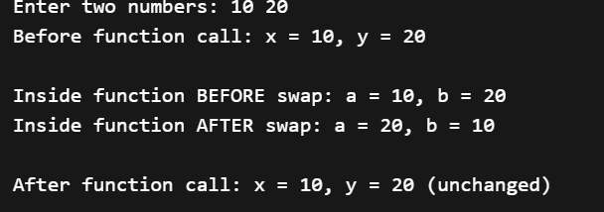
Swap using pointers
#include <stdio.h>

void swapWithPointer(int *a, int *b) {
int temp;

temp = *a;
*a = *b;
*b = temp;
}

int main() {
int x, y;

printf("Enter two numbers: ");
scanf("%d %d", &x, &y);

printf("Before swap: x = %d, y = %d\n", x, y);

swapWithPointer(&x, &y);

printf("After swap: x = %d, y = %d\n", x, y);

return 0;
}

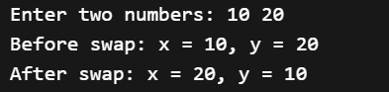
INPUT: Two integer numbers.

OUTPUT: Displays swapped values using both call by value and call by reference methods.

SAMPLE INPUT:
Enter two numbers: 10 20
SAMPLE OUTPUT:
After swapping without pointers:
a = 20 b = 10
After swapping with pointers:
x = 20 y = 10

CONCLUSION: Thus, the C program successfully demonstrates the difference between swapping values using call by value and call by reference. Using pointers allows the function to modify the original variables directly.

FAQs:
- What is the difference between call by value and call by reference in C?
- How do pointers help modify original variables inside a function?
- Why is swapping using pointers more effective in certain programs?

